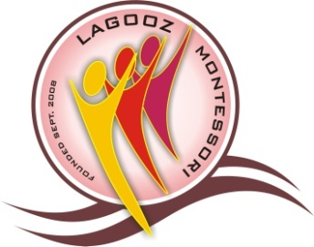

CENTRE FOR ACADEMIC THE REGISTRY AND

EXCELLENCE & SELF-RELIANCE PUBLIC RELATIONS OFFICE
HEAD OFFICE: 11/12 OMOTOYE ESTATE ROAD, LAGOOZ COLLEGE, ORILE AGEGE, LAGOS

ORILE AGEGE, LAGOS TEL: 08033205357, 08023852010
ANNEX: 31, COKER STREET, FUNMILAYO B/STOP www.lagoozschools.com
ORILE AGEGE, LAGOS. www.lagosacademy.5u.com
E-mail: lagoozcollege@yahoo.com lagosacademy@yahoo.com

NEWSLETTER FOR MID FIRST TERM, 2015/2016 SESSION
We thank Almighty God for giving us a good start this 2015/2016 academic session. The session commenced on 14th September, 2015 and since then, there has been commendable academic progress.

APPRECIATION
We appreciate parents/guardians who have been making meaningful contributions through their organization, Parent-Teacher Association (PTA). In fact, those parents/guardians who have not been attending P.T.A meetings are missing a vital aspect of their contributions towards the growth of their children/wards. The organization has been very active.
ACTIVITIES FOR THE REST OF THE TERM
The following are the activities for the rest of the term:
- Teachers’ award by P.T.A- 7th Nov; 2015
- Heat (Sport) – 14th Nov; 2015
- Examination – 23rd Nov; 2015
- Marathon Race – 28th Nov; 2015 (Parents are invited)
- MSSN- 4th Dec; 2015
- Health Walk – 5th Dec; 2015
- Sport Festival- 12th Dec; 2015
- Carol- 15th Dec; 2015
- Primary Party – 16th Dec; 2015
- Secondary Party- 17th Dec; 2015
- Vacation- 18th Dec; 2015
Parents/guardians are required to participate in the Marathon race on 28th November fully dressed in sport outfit.

NEW UNIFORM
The new school uniform for the secondary school students will be distributed to them before the end of the term. Primary school pupils will receive theirs at the beginning of the second term, that is, before the end of February, 2016. Parents/guardians should ensure that those uniforms are not tampered with by the students and pupils.

LAGOOZ SPORT FESTIVAL
Lagooz Sport Festival will take place on 12th December, 2015 at Agege Stadium. However, a marathon race involving parents/guardians, Lagooz staff and students comes up on 28th November, 2015.
Once more, we are grateful to you parents/guardians for your unflinching support.

………………………….
Chief/Mrs E.O. Otubela
Principal

